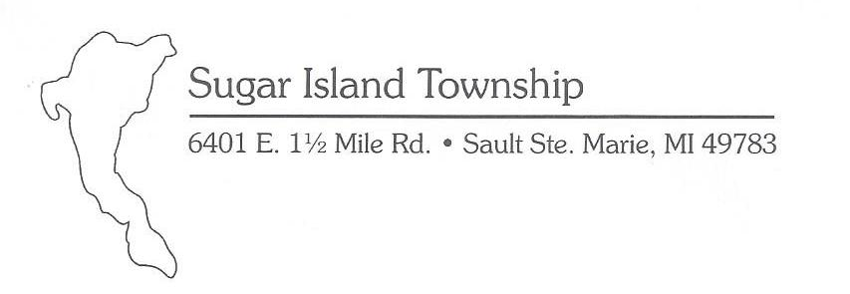
Phone: 906-253-9353 Fax: 906-635-9886
Email: sugarislandtwpclerk@wildblue.net

CODE ENFORCEMENT COMPLAINT FORM
It is the intent of the Sugar Island Township Board to resolve a complaint and/or achieve voluntary compliance in a timely manner. The property owner is ultimately responsible for bring the property into compliance as per zoning, building, health and safety and related codes, regulations and ordinances. In instances of disputes between neighbors these complaints may be referred to dispute resolution or civil court for action. Complaints pertaining to imminent health hazards will be referred to Chippewa County Health Department. All complaints MUST be filled out completely AND SIGNED by the complainant.

Violation Location and Property Owner
Street Address: _________________________________________________________________________________
Additional location Information: ___________________________________________________________________
Name of Property Owner: _______________________________________________Phone # __________________
Property Owner’s Mailing Address: _________________________________________________________________
Reporting Party Information
Reporting Party Name: (Print)___________________________________________Phone # ___________________
Mailing Address: ________________________________________________________________________________
Nature of Complaint (please be specific in describing what complaint is about) Photo’s attached. Yes No

Signature of Reporting Party (identity of reporting party is considered confidential) Can you provide access to property?
____________________________________________________________________Date: ______________________
For Official Use Only
Received by: ______________________Date Rec’d ____________________
Given to Zoning Enforcement Officer Yes/No Date: ________________________

